**Digital System Design**

**ASSIGNMENT REPORT**

**TEAM MEMBERS:**

1- Team Leader: *Khaled Ayman Anwar Khalil Eissa, Tut: T-11, ID: 49-3005, Email:* [*Khaled.anwar@student.guc.edu.eg*](mailto:Khaled.anwar@student.guc.edu.eg)

*2- Member: Hossam Ahmed Samy Elesawy ,Tut: T-9, ID: 49-8954, Email:* [*Hossam.elesawy@student.guc.edu.eg*](mailto:Hossam.elesawy@student.guc.edu.eg)

*3- Member: Karim Mohamed Atef Elshawadfi, Tut:T-19, ID:46-1663, Email:* [*karim.elshawadfi@student.guc.edu.eg*](mailto:karim.elshawadfi@student.guc.edu.eg)

*4- Member: Mohamed Ibrahim Mohamed Maher Dawod, Tut:T-9 ,ID:49-16488 ,Email:* [*Mohamed.dawod@student.guc.edu.eg*](mailto:Mohamed.dawod@student.guc.edu.eg)

*5- Member: Youssef George Youssef Faltaous, Tut: T-10, ID: 49-0568 Email:* [*Youssef.faltaous@student.guc.edu.eg*](mailto:Youssef.faltaous@student.guc.edu.eg)

**TEAM NUMBER : 66**

**1- THE IDEA:**

-Design a 3-bit adder on the DE10-lite FPGA board using 6 switches (3 for each input). The sum should be displayed using 4 LEDS representing the 4-bit sum. Output the result on two of the 7-segment displays. (BCD addition)

**2-Components:**

1- ALTERA FPGA board

2- LEDs

3- Switches

4- Seven segments

**3-THE IMPLEMENTATION:**

**1- CODE:**

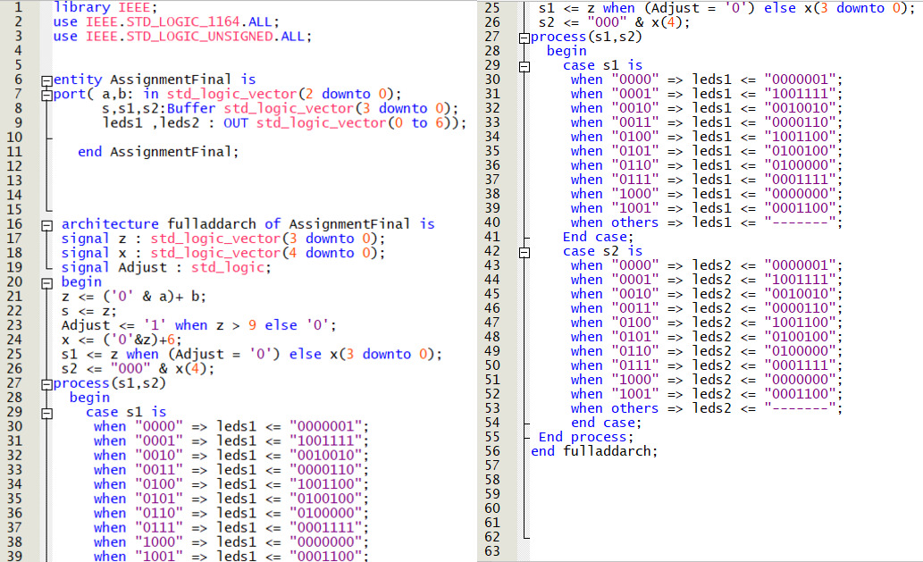

**1- PIN ASSIGNMENTS:**

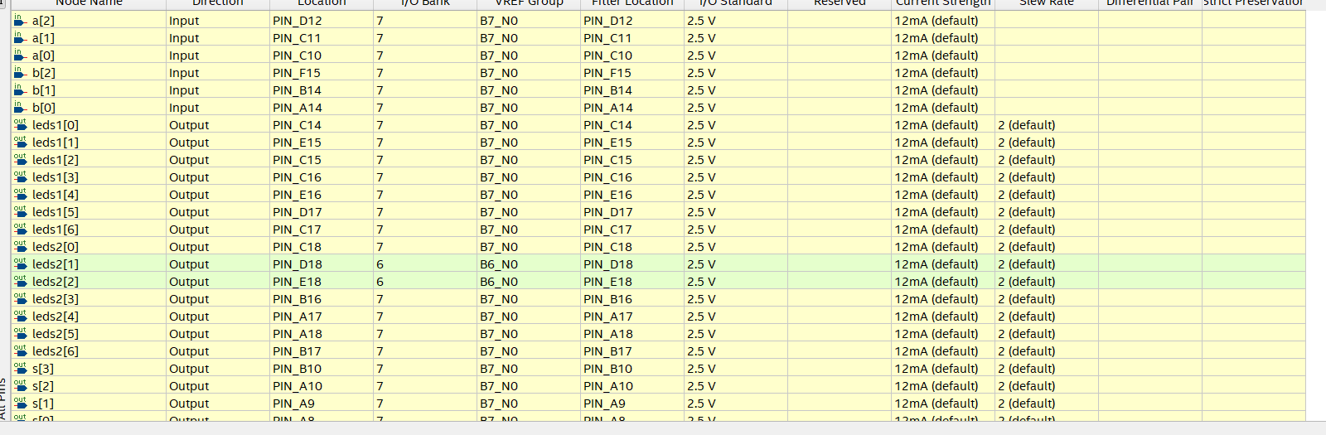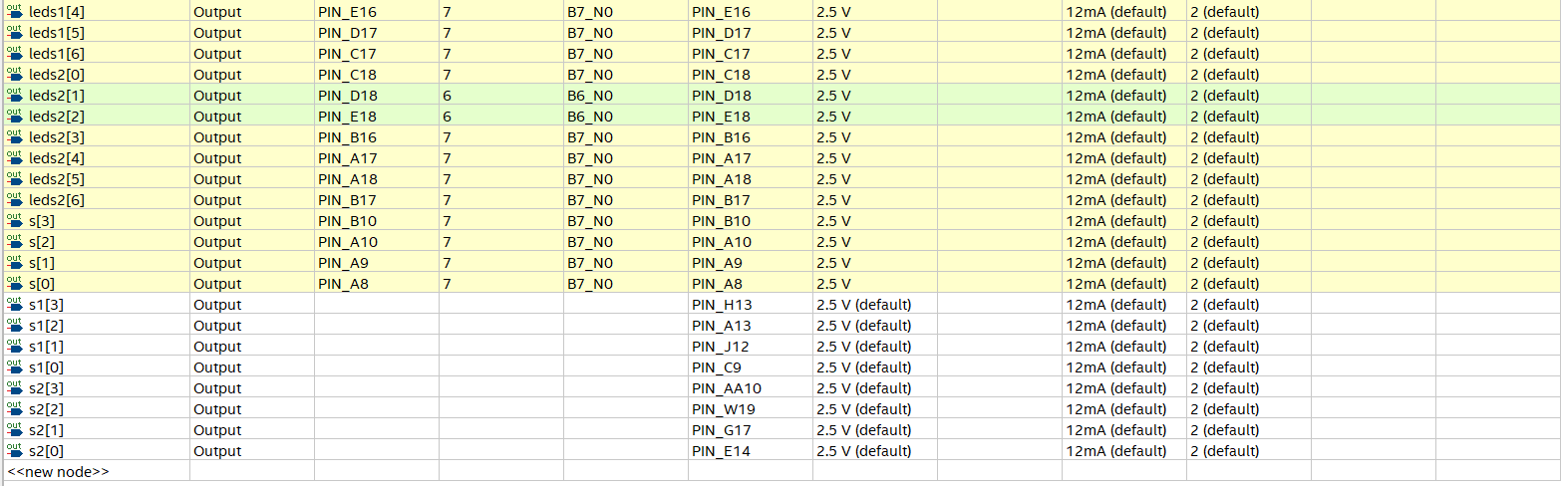

**1- PIN TOPS:**

